

**SVKM’s NMIMS**

**Mukesh Patel School of Technology Management & Engineering, Shirpur**

**A REPORT ON**

**“Online food ordering system”**

By

Charvi Hasaliya (B219/70021119021)

Dhairya Desai (B212/70021119012)

Pranav Kolhe (B228/70021119028)

B.Tech / MBA Tech (Computer Engineering) III Year

Academic Year 2021-22

# **“Online Food Ordering System”**

# **ABSTRACT: -**

An Online Food Ordering System is proposed here which simplifies the food ordering process. The proposed system shows an user interface, home page of the restaurant and the menu with all available options so that it eases the customer work. Customer can choose more than one item to make an order.

The user interface works with the help of php and MySQL whereas the cart functionalities in menu page like making the add to cart button work or increasing the amount of food item added to cart and showing the total amount of bill when the items are added and then when we go to the address page where the address of user is taken and when user presses the logout button on billing address page he/she is directed to the login page again.

# **INTRODUCTION**

With the advancement in technology every industry is trying to make use of it to make their work easier. The food industry is also advancing and making the use of technology by making their own social media handles for marketing and ordering sites to make their and customers work easier.

The food industry is highly labour intensive and the biggest expense in the food industry is the cost of employing the right kind of people to do the work. One of the ways to reduce this expense is to use modern technology to replace some of the jobs done by human beings and make machines do the work. Here we propose an “Online Food Ordering System” that has been designed for Fast Food restaurant, College Cafeterias etc. This simplifies the process of food ordering for both the customer and the restaurant, as the entire process of taking orders is automated.

With the help of this system, people can easily order the food. It can also ensure that the people do not waste their precious time and use their time productively in the other works. In long run, this will ensure that it helps to reduce labour cost. It is very easy to use and has least maintenance.

## **PROBLEM STATEMENT AND SOLUTION**

The problems faced while setting up a restaurant. Some of the problems found during the survey in the existing system are listed below:

• To place the orders customer visits the restaurant, checks the menu items available in the restaurant, and chooses the items required, then places the order and then do the payment. This method demands manual work and time on the part of the customer.

• When the customer wants to order over the phone, customer is unable to see the physical copy of the menu available in the restaurant, this also lacks the verification that the order was placed for the appropriate menu items.

• Every restaurant needs someone or the other to take the order personally or over phone, to offer the customer a rich experience and even to process the payment.

* And one common solution to all these problems is an online food ordering system. This system solves all the three problems.
* The customer doesn’t need to visit the restaurant to place its order.
* The user can pay the bill at the time of delivery.
* Menu is available on the ordering system and the items he wishes to order are visible in the cart along with their respective quantities and the amount of bill that customer has to pay.
* With the help of this system there is no need of some person to take the order personally.

## **LIST OF TECHNOLOGIES USED**

* HTML
* CSS
* Both used for the front-end.
* JavaScript
* In short JavaScript is used to make the menu page work.
* The add to cart button, increasing the quantity of food items, removing an item from cart or billing the purchases of customer are done with the help of event listener and other functionalities of JS.
* PHP
* Firstly, it is used to connect the page to database.
* For registration page it is used in form validations like checking if the user is already registered, the password and confirm password are same or if the email id is in correct format.
* For login page it is used to see if the customer is a registered user or not, or if the email/password entered by the customer is correct or not, if its correct it leads the customer to homepage.
* Also used to create the logout page, it basically destroys the session when logout button is clicked.
* MySQL
* It is used to store the data entered by customer to register itself on the website.
* When the customer wishes to login he/she enters the username and password; the entered details are confirmed with the details previously filled by the user while registration which are stored in a database.

## **PROJECT GALLERY**

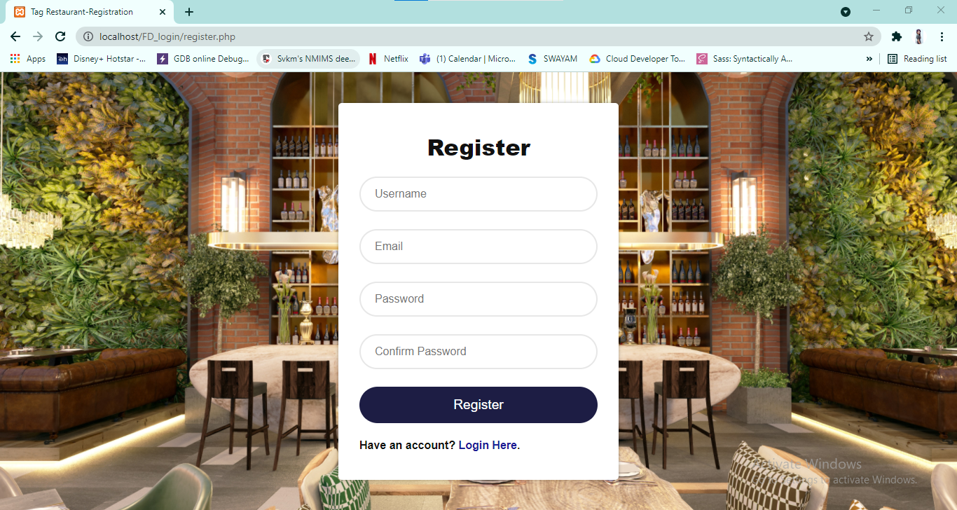

Figure 1: Registration Page

Customer can register itself if she/he doesn’t have an account. And then go to login page with link help of the link provided.

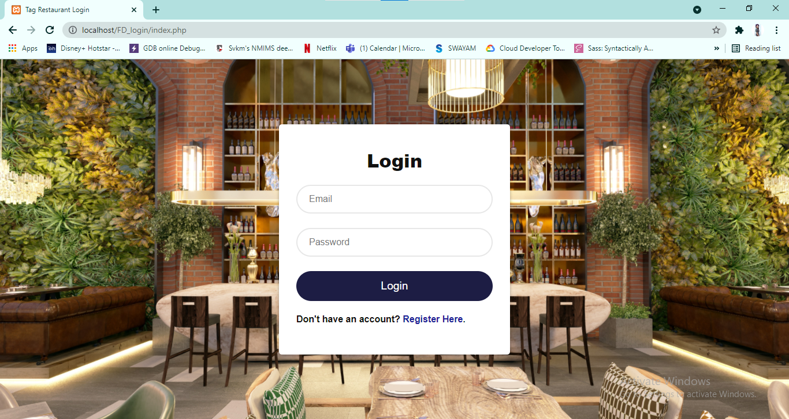

Figure 2: Login page

Customer can login from here.

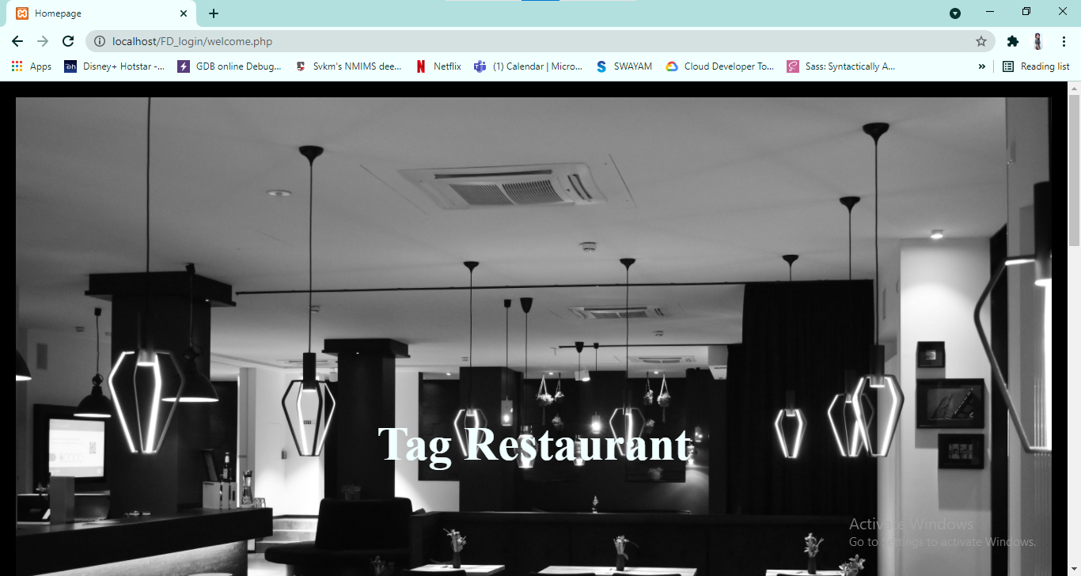

Figure 3: Homepage

Homepage displays the location and opening hours of the restaurant.

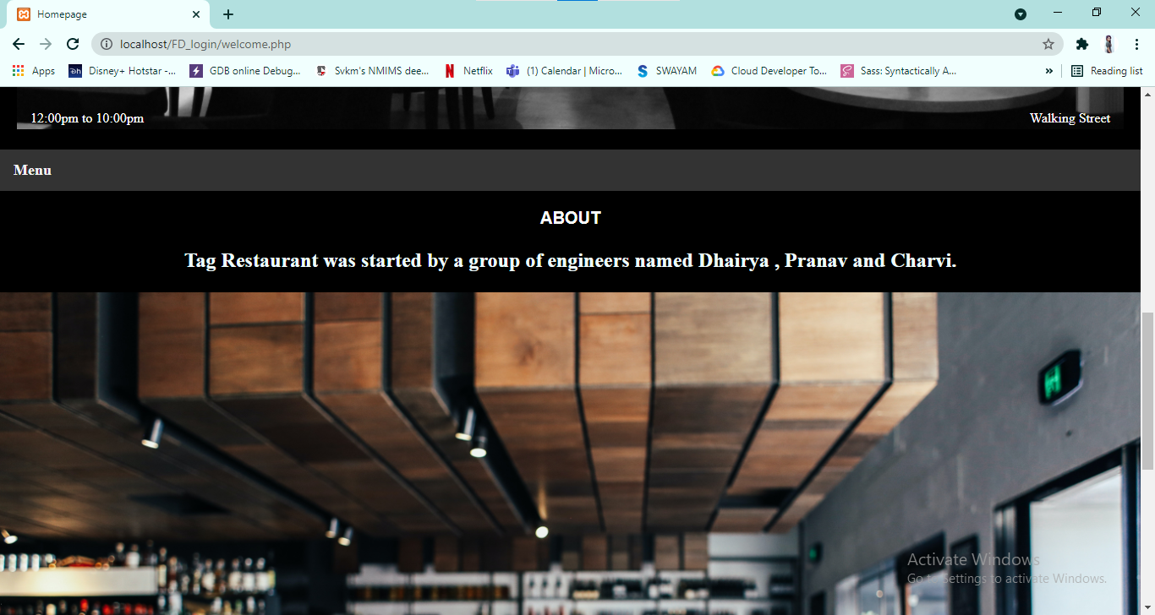

Figure 3a: Homepage

Customer can see the menu of restaurant by clicking at the menu tab.

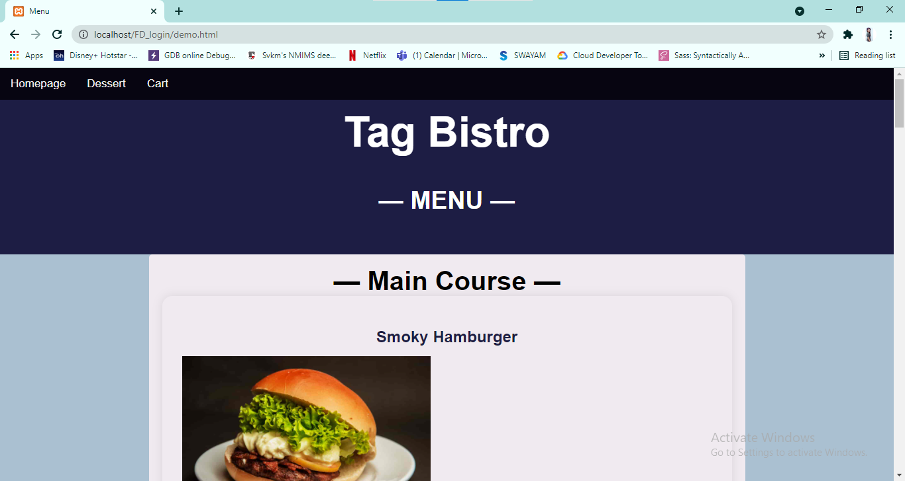

Figure 4a: Menu page

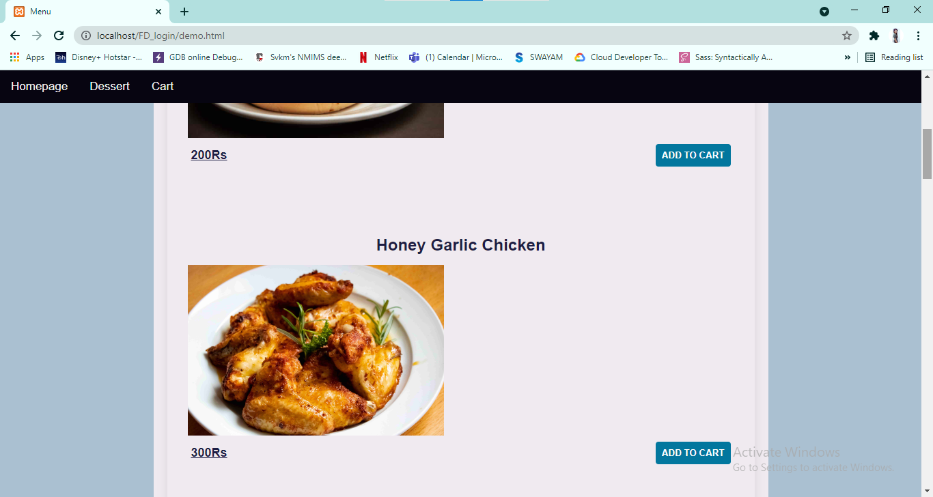

Figure 4b: Menu page

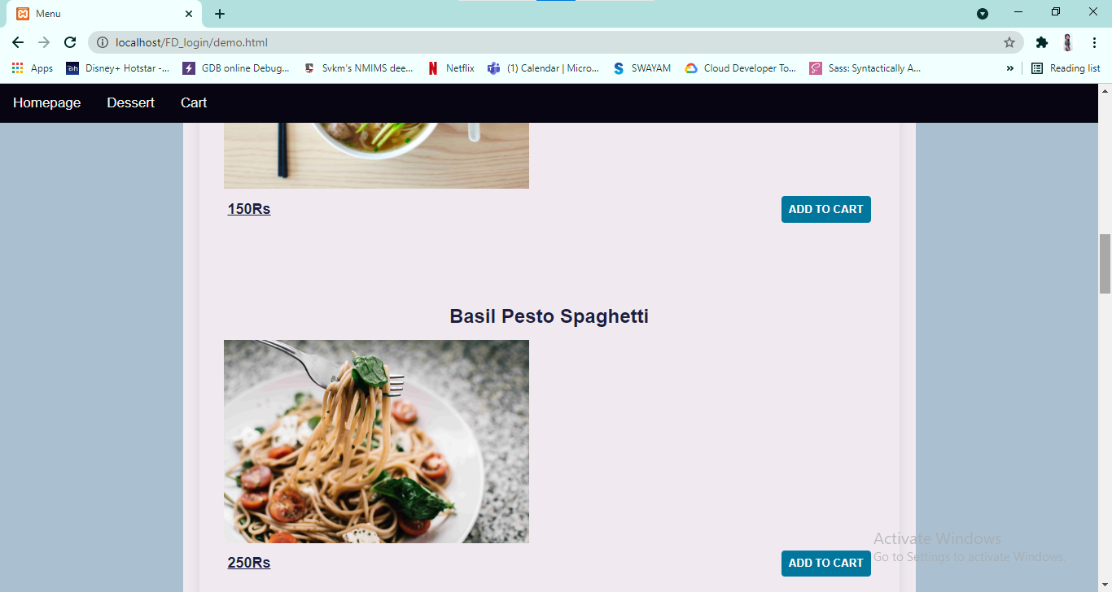

Figure 4c: Menu page

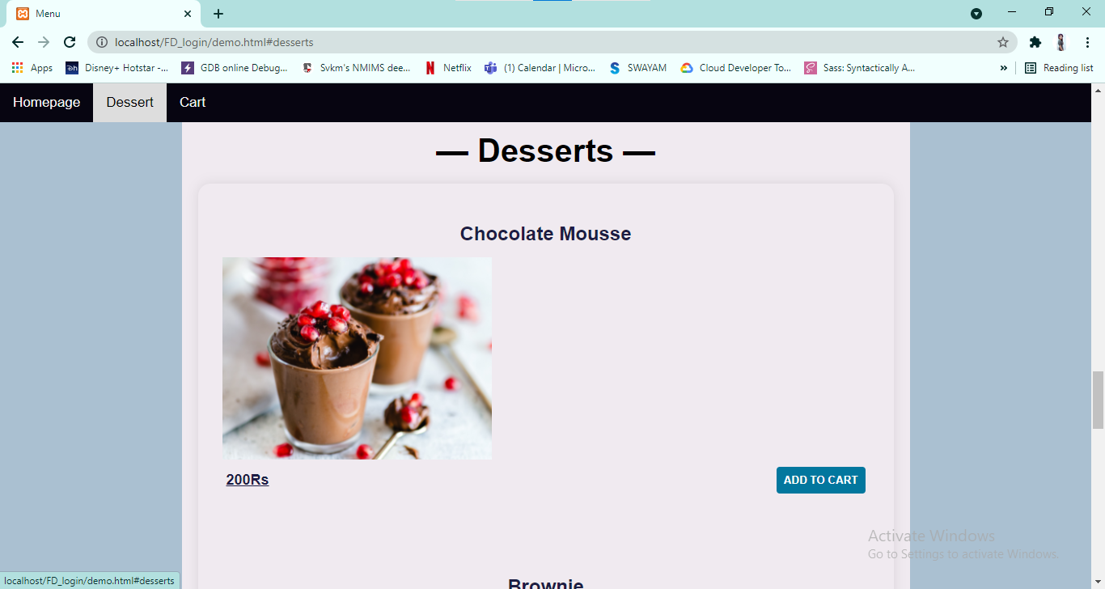

Figure 4d: Menu page

One can directly access the dessert menu or go to the cart with the help of navigation bar provided.

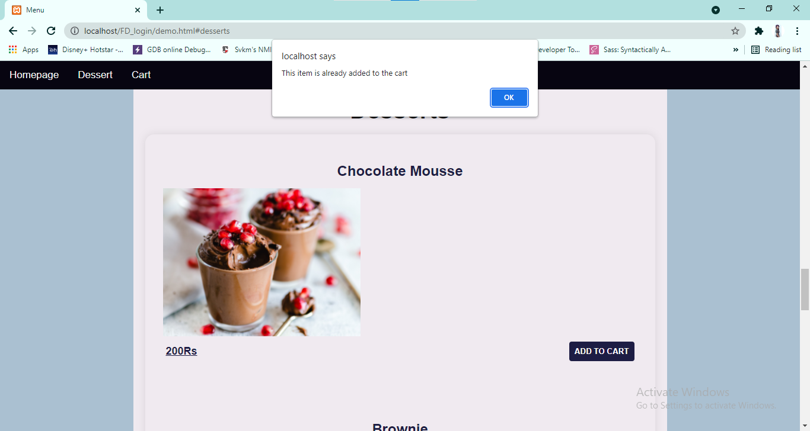

Figure 4e: Menu page

It displays a message if the customer tries to add item more than once.

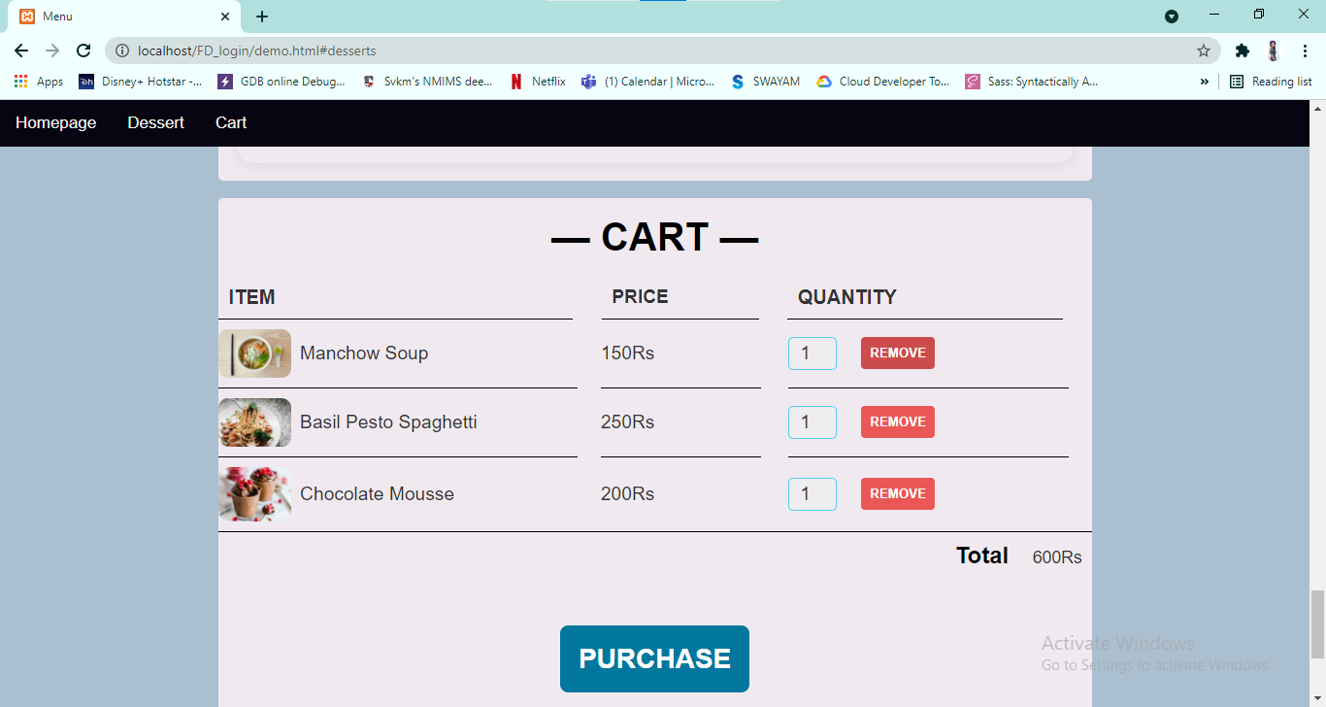

Figure 5a: Cart(menu page)

Customer can remove items from the cart.

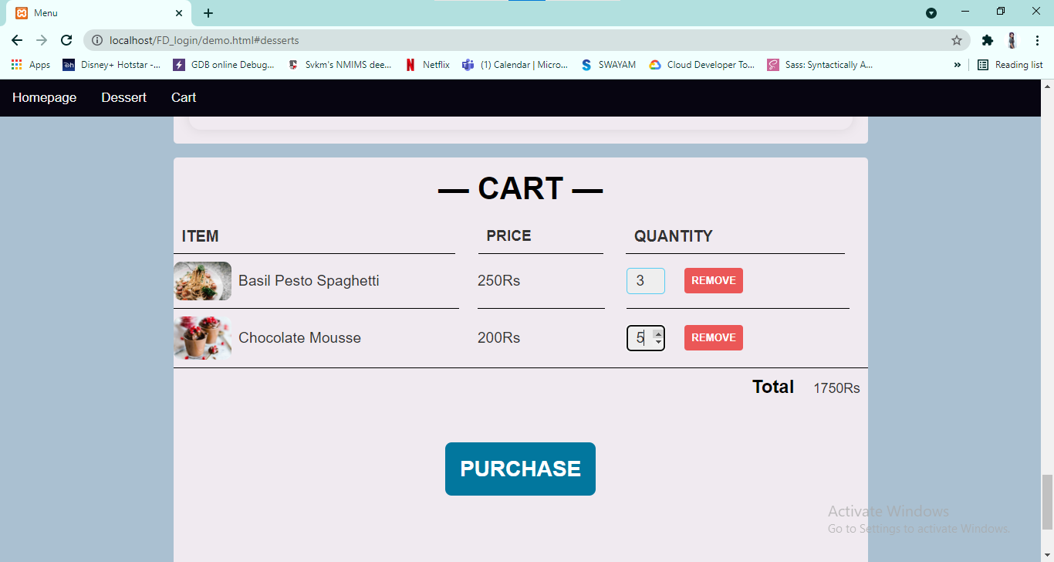

Figure 5a: Cart(menu page)

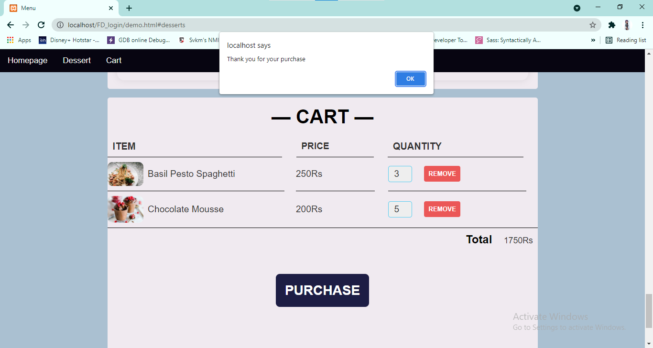

Figure 5b: Cart(menu page)

Customer can also increase the quantity of food items.

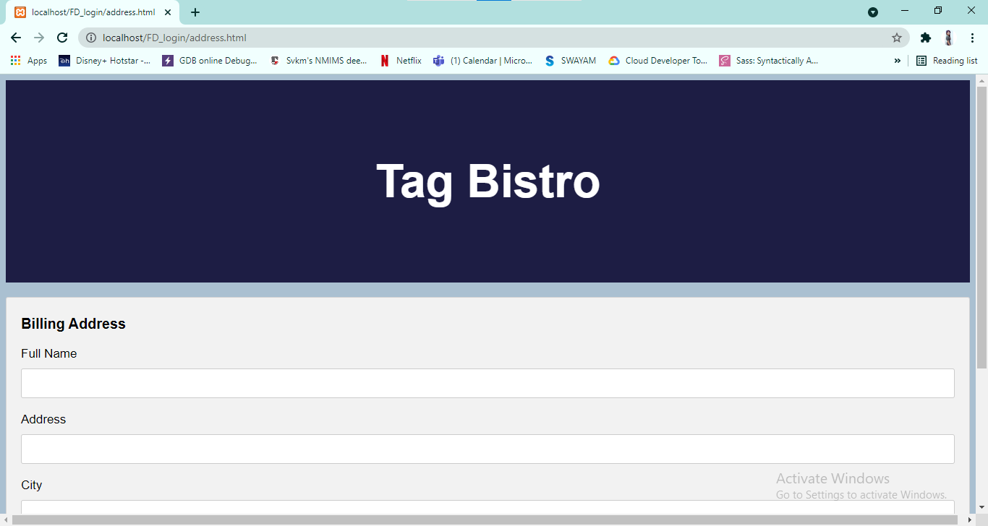

Figure 6a:Address page

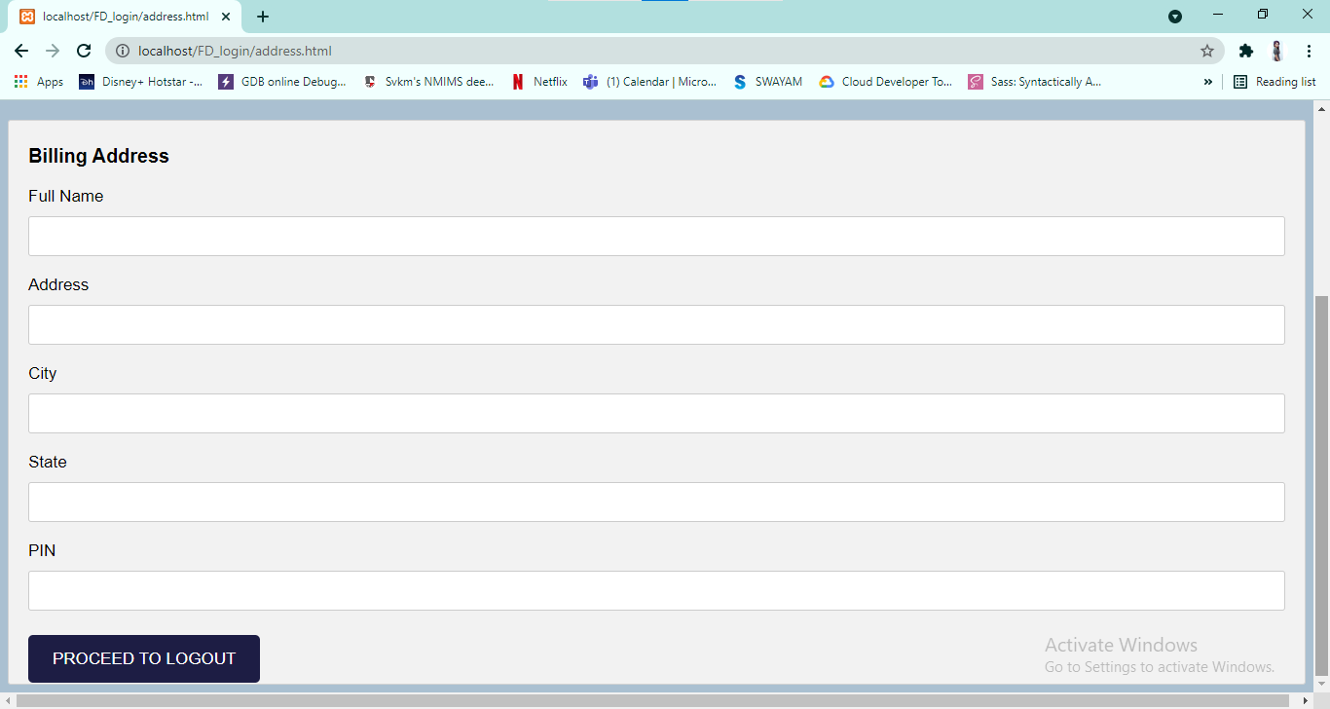

Figure 6b:Address page

By clicking on logut it leads you to the login page again.

**4.1 Database Created**

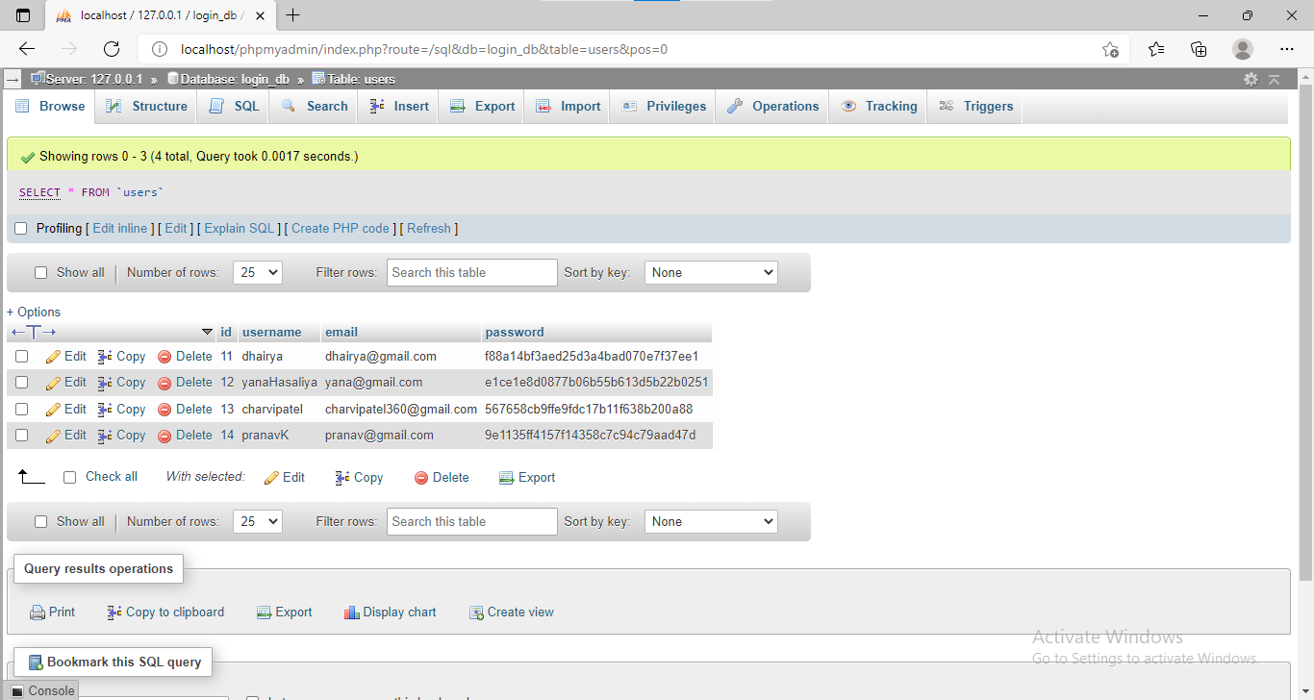

**CONCLUSION**

An online food ordering system is developed where the customers can make an order for the food and avoid the hassles of waiting for the order to be taken by the waiter. Using the application, the end users register online, read the menu card and select the food from the menu card to order food online. Therefore by using this application, the users can directly place the order for food to the restaurant online.

In conclusion an online food ordering system is proposed which is useful in small family run restaurants as well as in places like college cafeteria, etc. This project can later be expanded on a larger scale. It is developed for restaurants to simplify their routine managerial and operational task and to improve the dining experience of the clients. This also helps the restaurant owners develop healthy customer relationships by providing reasonably good services.

**REFERENCES**

Youtube

GeeksForGeeks

Developer Morzilla